

**Sauncey Wood Primary Newsletter**

**Friday, 15th January 2021**

Dear Parents and Carers,



I hope you all had a lovely Christmas and managed to spend time together as a family.

We have started the Spring term with a bit of a bang and not a bang that anyone wanted but we do understand that the situation we find ourselves in is vital to help slow the spread of this devastating pandemic. We are back to remote home learning with school open to only our key worker and vulnerable children. THANK YOU for all you are doing to support your children in their learning- it is very much a joint effort during these times more than ever.

Believe me, I understand that home schooling is tough, extremely tough at times; many of our teaching staff are juggling this new work/ life balance too! Yours and your family’s mental health and well-being must come first in these difficult times. Yes, completing some home learning is important (especially reading!) but do not feel bad if you spend a day building dens, going for a very long walk or cooking instead of completing a task on Purple Mash or attending a Zoom. It is very much about what you and your families can manage with your children and we are all only human; unfortunately, none of us are superheroes!

Also remember that we are on the end of a phone or email if things get tricky and you need a chat or some help; we will do our best to support you however we can.

Friendships during these time are invaluable. I would encourage you to make a Zoom play date and not to neglect friendships- colouring together whilst on a Zoom call; building Lego or playing a game whilst talking to a friend will raise your child’s mood and ensure that when we do return to school, those friendships remain strong.

Have a relaxing weekend,

Miss Harkness

**Thank you…**

I am sure all of you will join me in saying a huge thank you to our staff team. With less than a day’s notice, we were ready to provide remote learning and the school was open for our keyworker and vulnerable children. The staff team continue to work hard delivering remoter learning and being in school to support the bubble too. If you think your child’s teacher is doing a great job, I know an email to say thanks would be very much appreciated. **Maybe not just Superhero’s wear capes…**

**School News**

**Mr Lloyd welcomes Baby Phoebe**

As you may have seen on our Facebook page, Mr Lloyd and his wife have welcomed a new baby girl to their family. Baby Phoebe was born safe and well on the 5th of January. They are doing very well and settling into new routines. Mr Lloyd asked me to pass on his thanks to you for all your best wishes.

**New School Kitchen**

Over Christmas, work began on installing our new school kitchen. It is going to be a fabulous space where children will be able to develop their Design and Technology skills and learn all about healthy eating.

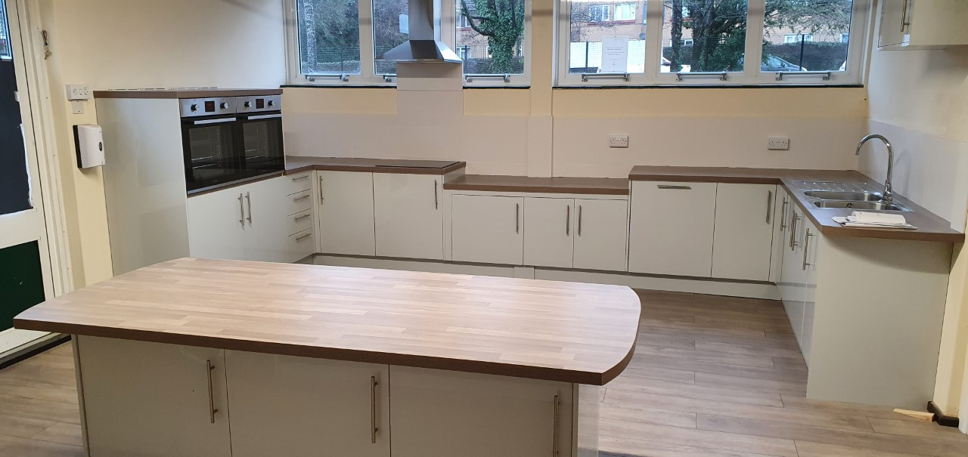

Our next step is to equip the kitchen with all the resources needed to be able to deliver high quality teaching and learning. The FOSW continue to work hard to plan events in line with Government guidance to raise vital funds. There is a Valentine’s trail taking place so do support if you can. Have a look at the Friends of Sauncey Wood page to keep up to date with events and how you can help too.



**Governor Corner**

Colin & Bridgett

Governing Body Co-Chairs