Friday 19th April 2024
Dear Parents and Carers,
I have loved my first week at Sauncey Wood Primary School. Everyone has made me feel so welcome and I already feel part of the Sauncey Wood community – thank you so much. Thank you also for sharing with your children the latter I sent them at the end of the Easter holidays. Almost every child had seen it and I know this is something that helped children feel less worried about returning to school this term.
Monday started with a whole school assembly where I shared with children and staff my three expectations:
- All adults do the best they can to help all children learn well and make friends.
- All children do the best they can to learn well and make friends.
- Everything to be kept neat and tidy.
So what do these mean?
- All adults do the best they can to help all children learn well and make friends. I expect adults to do this by:
- Making lessons interesting so that all children want to learn.
- Help children who find learning tricky.
- Make lessons challenging for children who find learning easy.
- Listen to children when they have a problem.
- Show children you are interested in them by chatting to them and asking them questions.
- All children do the best they can to learn well and make friends. I expect children to do this by:
- Always trying their best in every lesson
- When learning is tricky, try a different method, use the resources, ask a friend to help…
- When the learning is too tricky, tell and adult the learning is too tricky and ask them to help you.
- When the learning is too easy, tell and adult why it is easy. It is their job to check this and to make the learning more challenging for you.
- Be kind, friendly, helpful, respectful and inclusive. Chat to other children and ask them questions.
- Everything to be kept neat and tidy. This week, the focus has been on KS2 children keeping their belongings inside their lockers, not on top! They have done this brilliantly, as the before and after pictures show.
Before After
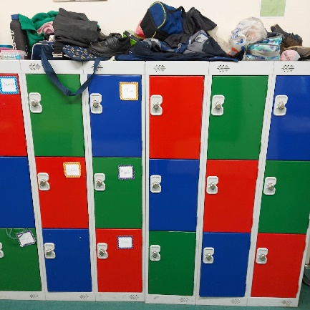
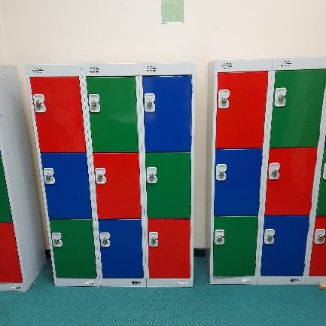

Staff have also been doing their bit to keep everything neat and tidy. We have been have a thorough clear out – you may have seen the skip on the grass between the carpark and the playground.

School Uniform
Next week, I want one of the focus areas to be school uniform so that children wear their uniform with pride. Most children are wearing polo shirts, sweatshirts etc as per the school uniform policy. However, there are lots of children wearing trainers to and from school and this does not present the school in a good light in the local community. The uniform policy states:
Black school style shoes – plain flat – no open toes, no trainers.
I expect all children to wear the correct uniform. This is good preparation for secondary school but also the world of work where there are often dress codes to follow. If you need to check the school’s expectations around school uniform, please refer to the school website: https://www.saunceywood.herts.sch.uk/uniform
If you need support in buying uniform, please speak to the staff in the school office or come and chat to me. We have a lot of very good quality pre-loved uniform available.

Celebration Assemblies
I know this news will disappoint some of you. While parents and carers are welcome to attend celebration assemblies by joining us in person in the school hall, we will no longer send a link for parents to join virtually. My reasons are: the school has no control over whether parents are filming/recording the assembly if they are attending virtually; there are some children who should not be filmed at the request of their parents; the behaviours of some parents online has been a distraction to the children, including parents taking phone calls and eating and drinking. In the letter you received from me before term started, I said children are always at the heart of every decision I make. This is a good example of that. I hope you will understand that this decision has been made because I want to protect the children.

Staffing update
Today is the closing date for our Headteacher vacancy and I am very pleased to let you know that three candidates who visited the school this week have applied for the role. It was my pleasure to show them around the school and chat to them about Sauncey Wood and I am delighted they have decided to apply. There will be further information on this ponce the selection process is completed at the beginning of May.
Ms Webb, or Interim Deputy Headteacher, was appointed to the role for one year. The permanent role of Deputy Headteacher is being advertised and I am looking forward to showing prospective candidates around the school. We are hoping that the candidate who is appointed to the role of Headteacher, will be available to be part of the selection panel for the new Deputy Headteacher.
Other news
Thank you to Mrs Thompson (Y1 teacher and the school’s maths leader) for organising a successful maths day on Wednesday.
Yesterday, I had the pleasure of working with Colin Noakes and Michelle Saas, our Co-Chairs of Governors. We attended a whole day training course called Knowing Your School: Preparation for Ofsted. Sauncey Wood is due an Ofsted inspection this term and it was good to spend the time with them talking about the school’s priorities and the progress it is making.
I am currently confirming events for the summer term and these will be sent to you next week so that you know when events such as sports day, open evening and the Y6 leavers’ assembly are taking place.

I hope you all have a lovely weekend
Eileen Anderson
Interim Headteacher

