**Mountains and Europe**

A mountain is a landform that is much higher than the land around it. Mountains are steeper than hills and are formed when tectonic plates on the Earth’s crust push together to force the ground upwards where they meet. Alternatively, mountains can be formed when molten rock bursts through the Earth’s surface and builds up, creating a volcanic mountain!

Europe is our continent, located entirely in the Northern Hemisphere and mostly in the Eastern Hemisphere. It is bordered by the Arctic Ocean to the north, the Atlantic Ocean to the west, the Mediterranean Sea to the south, and Asia to the east.

**Year 4**

**Spring**

**Geography**

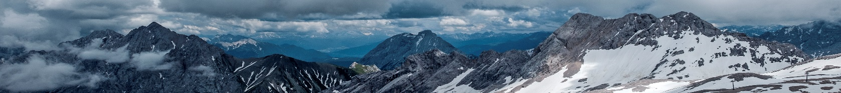

**Knowledge and Understanding**

In this unit pupils will learn;

**Mountains**

* Find out about the major mountains of the world and the UK. They find out the different ways in which mountains have been formed
* How different features of mountain ranges have been shaped over time.
* Consider what the weather is like in a mountainous environment
* Evaluate the impact that tourism has on a mountainous region.

**Europe**

* Identify the seven continents of the world before looking more closely at a map of Europe.
* Compare Europe with other continents in terms of its size and features
* Identify the seas and oceans surrounding Europe.
* Explore some human features of different European countries, including flags, currencies and governments.
* Learn the names of major capital cities in Europe before choosing two to compare.

**Key Vocabulary**

* continent (noun) a large collective of regions
* seas (noun) a portion of the ocean that is partly surrounded by land
* ocean (noun) a continuous body of salt water
* human features - things made or built by humans like cities, houses, roads,
* physical features - natural features on the earth's surface​
* capital city - where a region's government is located.
* National flag – the symbol of a particular nation
* currency - a system of money in a particular country
* government - a group of people who make decisions for a country, nation, or state
* range - a series of [mountains](https://en.wikipedia.org/wiki/Mountain) or [hills](https://en.wikipedia.org/wiki/Hill) arranged in a line and connected by high ground
* peak - the pointed top of a mountain or ridge
* altitude - the height of an object or point in relation to sea level or ground level
* slope - a slope is the side of a mountain
* summit - the highest point on a mountain
* climate - the weather conditions in an area in general or over a long period
* tourism - when people travel from where they live to another place for pleasure or relaxation

**Enquiry skills and Key concepts**

* Use maps, atlases, globes and digital/computer mapping to locate countries and describe features studied
* Use the eight points of a compass, four and six-figure grid references, symbols and key (including the use of ordnance survey maps) to build their knowledge of the united kingdom and the wider world
* Use fieldwork to observe, measure, record and present the human and physical features in the local area using a range of methods, including sketch maps, plans and graphs, and digital technologies.