

**Year 4**

**Spring 1**

**Science**

**Sound**

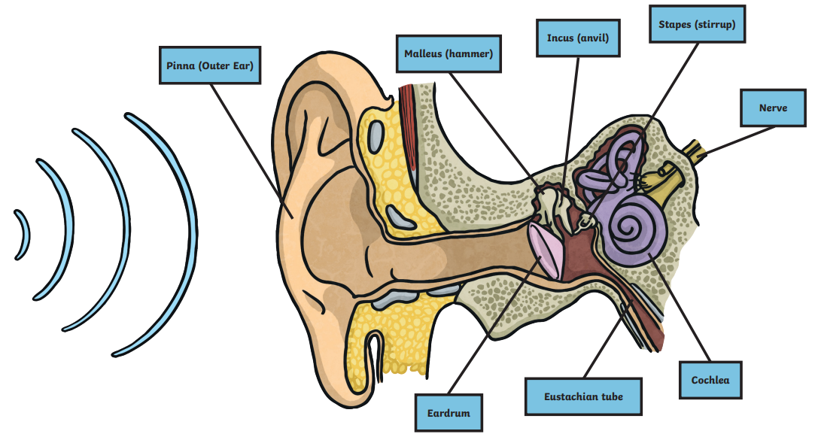

**Key Vocabulary:**

ear (noun) An organ used for hearing.

particles (noun) Solids, liquids and gases are made of particles. They are so small we are unable to see them.

Distance (noun) A measurement of length between two points.

soundproof (adjective) To prevent sound from passing through.

absorb (verb) sound To take in sound energy. Absorbent materials have the effect of muffling sound.

vacuum (noun) A space where there is nothing. There are no particles in a vacuum.

Eardrum (noun) A part of the ear which is a thin, tough layer of tissue that is stretched out like a drum skin. Sound waves make the eardrum vibrate.

Vibration (noun) A quick movement back and forth.

sound wave (noun) Vibrations travelling from a sound source.

volume (noun) The loudness of a sound.

amplitude (noun) The size of a vibration. A larger amplitude = a louder sound.

Pitch (noun) How low or high a sound is

**Knowledge and Understanding**

In this unit pupils will learn;

* identify how sounds are made, associating some of them with something vibrating
* recognise that vibrations from sounds travel through a medium to the ear
* find patterns between the pitch of a sound and features of the object that produced it
* find patterns between the volume of a sound and the strength of the vibrations that produced it
* recognise that sounds get fainter as the distance from the sound source increases.

**Enquiry skills and Key concepts**

The Children might work scientifically by:

* finding patterns in the sounds that are made by different objects such as saucepan lids of different sizes or elastic bands of different thicknesses.
* They might make earmuffs from a variety of different materials to investigate which provides the best insulation against sound.
* They could make and play their own instruments by using what they have found out about pitch and volume.