**The Vikings**

The Vikings came from the modern Scandinavian countries of Denmark, Norway and Sweden. They travelled in boats called long ships and first arrived in Britain around AD 787. The Vikings raided places such as monasteries and pillaged expensive items to trade. They were looking for valuable goods like gold and jewels, imported foods and other useful materials. The Vikings also wanted to claim land and tried to take over much of Britain. By AD 878 the Vikings had settled permanently in Britain.

**Year 4**

**Autumn**

**History**

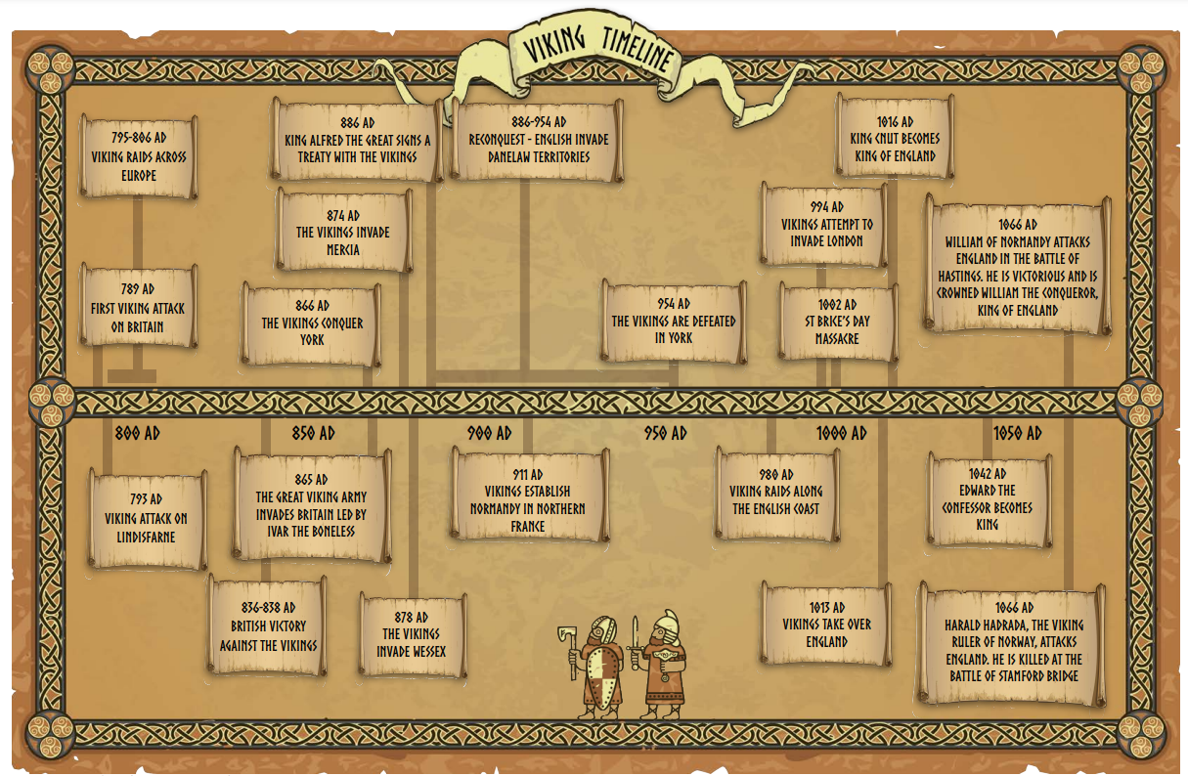

**Key Vocabulary:**

Dane (noun) Someone who is from Denmark.

Danegeld (noun) Payments of gold, silver or land given to the Vikings to make them go away when they came to raid a country.

invade (verb) Enter a country or area using force, with the aim of taking control of it.

longship (noun) A long, narrow ship made of wood and used by the Vikings.

monastery (noun) A place where monks live.

Norse (adjective) Used to describe someone or something that is from ancient Norway or the other countries where the Vikings came from.

pagan (noun) Someone who worships many different gods or goddesses.

pillage (verb) Rob somewhere or steal something in a violent way.

raid (verb) Carry out a surprise attack on a place, usually with the aim of stealing.

runes (noun) Letters in the system of writing used by the Vikings.

saga (noun) A long story or poem that the Vikings passed down through the generations.

trade (verb) To exchange one thing for another.

**Knowledge and Understanding**

In this unit pupils will learn;

* Where the Vikings came from and why they attacked.
* Know that the Vikings were a real threat from the sea.
* Locate the Vikings in time, in relation to the Saxons.
* Understand how the Vikings gained their reputation.
* How the Vikings tried to take over the country and how close they came.
* How recent excavations changed our view of the Vikings.

**Enquiry skills and Key concepts**

* Develop an awareness of the past, using common words and phrases relating to the passing of time.
* Know where the people and events they study fit within a chronological framework and identify similarities and differences between ways of life in different periods.
* Use a wide vocabulary of everyday historical terms.
* Understand some of the ways in which we find out about the past and identify different ways in which it is represented.
* Ask and answer questions, choosing and using parts of stories and other sources to show they understand.